SummAI: Business Summarization
Project Description:
SummAI is an advanced Natural Language Processing project designed to automatically generate concise summaries from lengthy business articles, reports, and emails. The system utilizes both extractive and abstractive machine learning algorithms to analyze text documents and provide accurate, meaningful summaries. By examining sentence importance, semantic relationships, and contextual understanding through state-of-the-art transformer models, the system assists business professionals in quick information extraction and decision-making. The project compares two distinct approaches: TextRank-based extractive summarization and BART-based abstractive summarization, evaluating their performance using industry-standard ROUGE metrics.

Project Scenarios :

Scenario 1: Executive Brief Generation
A C-level executive receives a 50-page quarterly market analysis report at 8 AM before a 9 AM board meeting. The SummAI system processes the entire document and generates both extractive and abstractive summaries within seconds. The executive can quickly understand key insights—market trends, competitor analysis, and revenue projections—enabling informed participation in strategic discussions without reading the full report.

Scenario 2: Email Inbox Management
A business analyst manages 200+ emails daily from various departments, clients, and stakeholders. Many contain lengthy project updates, technical specifications, and detailed discussions. SummAI processes these emails in bulk, providing 2-3 sentence summaries for each. The analyst can now prioritize responses, identify urgent matters, and save 2-3 hours daily on email management.

Scenario 3: News Monitoring and Competitive Intelligence
A corporate strategy team monitors hundreds of industry news articles, press releases, and competitor announcements weekly. SummAI automatically summarizes each article, allowing the team to scan 100+ summaries in the time it would take to read 10 full articles. This enables real-time market awareness and rapid response to competitive threats or emerging opportunities.

Technical Diagram:
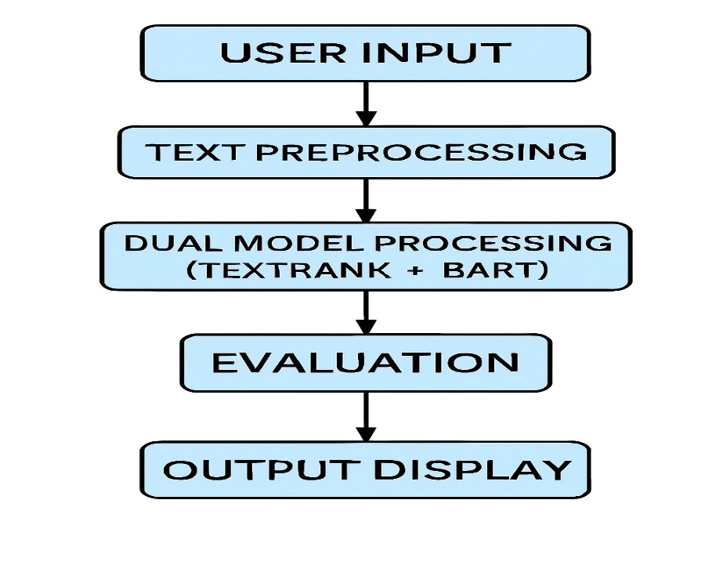
Flow Chart
Prerequisites:
To complete this project, you must require the following software, concepts, and packages:
Anaconda Navigator and Visual Studio:
- Refer to the link below to download Anaconda Navigator
- Link: https://youtu.be/1ra4zH2G4o0
Python packages:
Open anaconda prompt as administrator
Type
pip install numpy
and click enter.
Type
pip install pandas
and click enter.
Type
pip install transformers
and click enter.
Type
pip install torch
and click enter.
Type
pip install datasets
and click enter.
Type
pip install nltk
and click enter.
Type
pip install scikit-learn
and click enter.
Type
pip install networkx
and click enter.
Type
pip install rouge-score
and click enter.
Type
pip install Flask
and click enter.
Type
pip install matplotlib
and click enter.
Type
pip install seaborn
and click enter.
Prior Knowledge:
You must have prior knowledge of the following topics to complete this project.
NLP & ML Concepts

Natural Language Processing Basics: https://www.javatpoint.com/nlp
- Text Preprocessing: https://www.geeksforgeeks.org/text-preprocessing-in-python/
- Tokenization: https://www.analyticsvidhya.com/blog/2020/05/what-is-tokenization-nlp/
- TF-IDF: https://www.geeksforgeeks.org/understanding-tf-idf-term-frequency-inverse-document-frequency/
- Transformers & BERT/BART: https://huggingface.co/docs/transformers/index
- Graph Algorithms (PageRank): https://www.geeksforgeeks.org/page-rank-algorithm-implementation/
- Text Summarization: https://www.analyticsvidhya.com/blog/2019/06/comprehensive-guide-textsummarization-using-deep-learning-python/
- ROUGE Metrics: https://en.wikipedia.org/wiki/ROUGE_(metric)
Flask Basics:
htt
p
s://www.
y
outube.com/watch?v=l
j
4I_CvBnt
0
Project Flow:
- User enters or pastes business text (article, report, email) through the web interface
- System performs text preprocessing including sentence tokenization and cleaning
- Integrated dual machine learning models analyze the text:Extractive model (TextRank) selects key sentences
- Abstractive model (BART) generates new summary
- Both summaries are generated and displayed side-by-side
- System provides ROUGE score evaluation and comparison metrics
- User can choose preferred summarization method or view both
Project Activities:

Data Collection & Preparation
- Collect the CNN/DailyMail summarization dataset
- Data loading and exploration
- Text preprocessing and cleaning

Exploratory Data Analysis
- Dataset statistics and structure analysis
- Text length distribution analysis
- Sample article and summary review

Model Building
- Implementing TextRank extractive summarization
- Loading and configuring BART abstractive model
- Training and testing both approaches

Performance Testing & Model Selection
- Testing models with ROUGE evaluation metrics
- Comparing extractive vs abstractive performance
- Analyzing strengths and weaknesses of each approach
5
. Model Deployment
- Save the trained models
- Integrate with Flask Web Framework
- Deploy interactive web application

Project Structure:
Create the Project folder which contains files as shown below:

SummAI/
├── static/
│ └── style.css
├── templates/
│ └── index.html
├── app.py
├── extractive_model.pkl
├── SummAI_Notebook.ipynb
├── requirements.txt
└── Dataset/

└── (CNN/DailyMail dataset loaded via Hugging Face)
Project Structure Explanation

static/
Contains static assets (CSS, JavaScript) style.css – Application styling and responsive design

templates/
HTML templates for Flask application index.html – Main interface for text input and summary display

app.py
Flask application backend handling:
- Model loading
- Text preprocessing
- Summarization logic
- API endpoints

extractive_model.pkl
Saved TextRank model for extractive summarization

SummAI_Notebook.ipynb
Jupyter notebook containing:
- Data exploration
- Model implementation
- Performance evaluation
- Comparative analysis
requirements.txt
All Python dependencies and their versions

Dataset
CNN/DailyMail dataset (loaded dynamically via Hugging Face datasets library)

Milestone 1: Data Collection & Preparation
Data collection is fundamental to natural language processing and machine learning, providing the raw material for training algorithms and making predictions. For text summarization, high-quality paired data (original text + human-written summary) is essential. This process involves gathering relevant datasets from reliable sources such as Kaggle, Hugging Face, or research repositories. The quality, size, and diversity of collected data significantly impact the performance and accuracy of summarization models.

Activity 1.1: Collect the Dataset
There are many popular open sources for collecting NLP datasets. Examples include Kaggle.com, Hugging Face Datasets, and academic repositories. In this project, we use the CNN/DailyMail dataset, which is one of the most widely used benchmarks for text summarization research.
Dataset Source: https://huggingface.co/datasets/cnn_dailymail
The CNN/DailyMail dataset contains news articles paired with multi-sentence summaries. It is accessed programmatically through the Hugging Face datasets library, eliminating the need for manual downloads.
Dataset Details:
- Total Samples: 300,000+ article-summary pairs
- Training Samples Used: 1,000 articles
- Test Samples Used: 100 articles

Version: 3.0.0
- Source: CNN and Daily Mail news websites
- Quality: Professional journalism with human-written summaries
The dataset includes the following structure:
- article: Full news article text (input for summarization)
- highlights: Human-written bullet-point summary (reference/ground truth)
- id: Unique identifier for each article

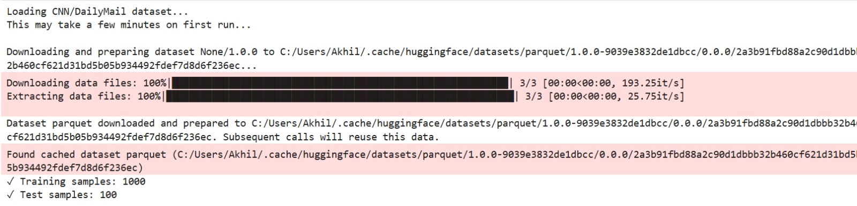

Activity 1.2: Importing the Libraries
Import the necessary libraries as shown below:

# Data manipulation and analysis
import
pandas
as
pd
import
numpy
as
np
# Dataset loading
from
datasets
import
load_dataset
# Natural Language Processing
import
nltk
from
nltk
.
corpus
import
stopwords
from
nltk
.
tokenize
import
sent_tokenize
,
word_tokenize
# Machine Learning and NLP utilities
from
sklearn
.
feature_extraction
.
text
import
TfidfVectorizer
import
networkx
as
nx
# Deep Learning and Transformers
from
transformers
import
pipeline
,
AutoTokenizer
,
AutoModelForSeq2SeqLM
# Evaluation
from
rouge_score
import
rouge_scorer
# Visualization
import
matplotlib
.
pyplot
as
plt
import
seaborn
as
sns
# Utilities
import
warnings
warnings
.
filterwarnings
(
'ignore'
)
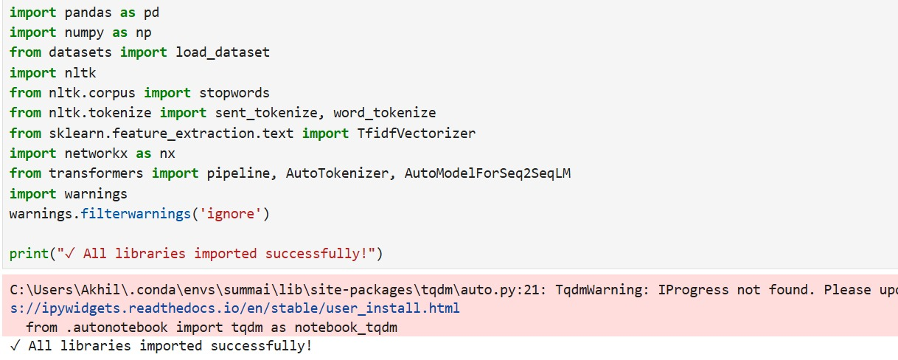These libraries serve the following purposes:
- Pandas & NumPy: Data manipulation and numerical computations
- Datasets: Loading CNN/DailyMail dataset from Hugging Face NLTK: Sentence/word tokenization and stopwords scikit-learn: TF-IDF vectorization for text similarity
- NetworkX: Graph algorithms for PageRank implementation Transformers: BART model for abstractive summarization rouge-score: Evaluation metrics for summarization quality

Matplotlib & Seaborn: Data visualization

Activity 1.3: Download Required NLTK Data
Before processing text, we need to download NLTK tokenization and stopword data:
python
# Download required NLTK data
nltk
.
download
(
'punkt'
,
quiet
=
True
)
nltk
.
download
(
'stopwords'
,
quiet
=
True
)
print
(
"
✓
NLTK data downloaded successfully!"
)

[INSERT FIGURE 5: NLTK download confirmation output]

Activity 1.4: Read the Dataset
Our dataset is loaded programmatically using the Hugging Face
datasets
library:
python
print
(
"Loading CNN/DailyMail dataset..."
)
print
(
"This may take a few minutes on first run...\n"
)
# Load training and test splits
dataset
=
load_dataset
(
"cnn_dailymail"
,

"3.0.0"
,
split
=
"train[:1000]"
,

verification_mode
=
"no_checks"
)
test_data
=
load_dataset
(
"cnn_dailymail"
,

"3.0.0"
,
split
=
"test[:100]"
,

verification_mode
=
"no_checks"
)
print
(
f"
✓
Training samples:
{
len
(
dataset
)
}
"
)
print
(
f"
✓
Test samples:
{
len
(
test_data
)
}
"
)
The dataset is now loaded into memory. Let's examine the structure:
python
# Check dataset structure
print
(
"\nChecking dataset structure..."
)
print
(
f"First sample type:
{
type
(
test_data
[
0
]
)
}
"
)
print
(
f"First sample keys:
{
test_data
[
0
]
.
keys
(
)
}
"
)
Output:
First sample type: <class 'dict'>
First sample keys: dict_keys(['article', 'highlights', 'id'])

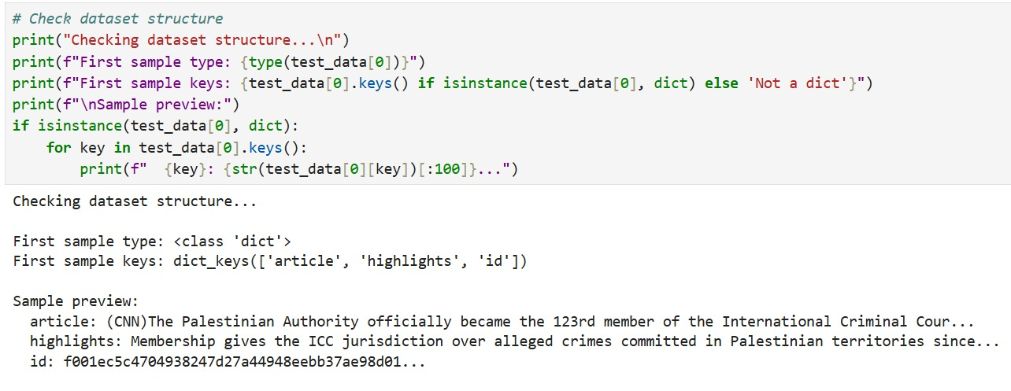

Activity 1.5: Explore Sample Data
Let's examine a sample article and its reference summary:
python
# Display sample article
sample
=
dataset
[
0
]
print
(
"Sample Article (first 500 characters):"
)
print
(
"="
*
60
)
print
(
sample
[
'article'
]
[
:
500
]

+

"..."
)
print
(
"\n"

+

"="
*
60
)
print
(
"Reference Summary:"
)
print
(
"="
*
60
)
print
(
sample
[
'highlights'
]
)
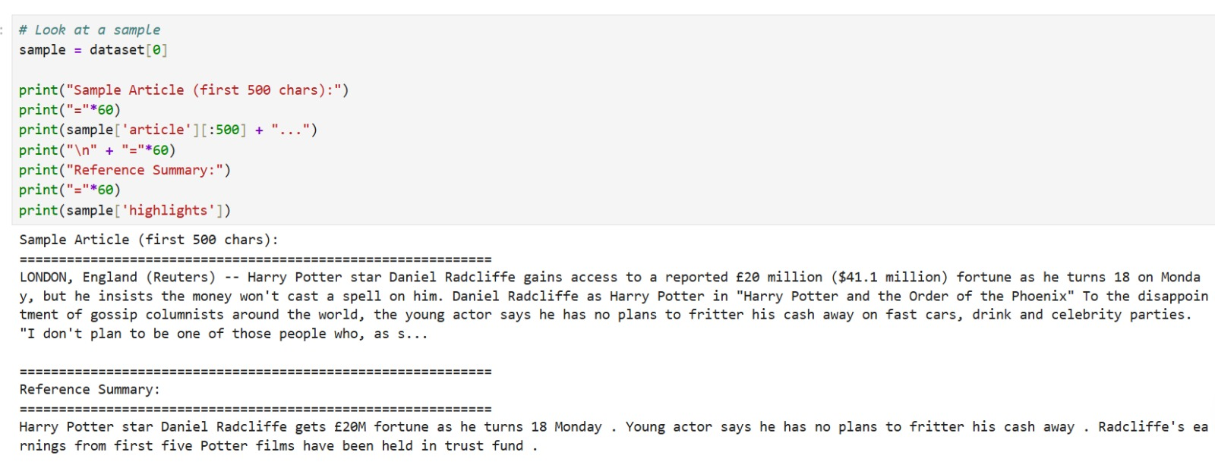This gives us a clear understanding of:
- Article length and writing style
- Summary format and length
- Information compression ratio

Activity 1.6: Data Preparation
For our text summarization task, the CNN/DailyMail dataset comes pre-cleaned. However, we still perform validation checks:

Step 1: Verify Data Integrity

# Check for any empty articles or summaries
empty_articles
=

sum
(
1

for
item
in
dataset
if

not
item
[
'article'
]
.
strip
(
)
)
empty_summaries
=

sum
(
1

for
item
in
dataset
if

not
item
[
'highlights'
]
.
strip
(
)
)
print
(
f"Empty articles:
{
empty_articles
}
"
)
print
(
f"Empty summaries:
{
empty_summaries
}
"
)

Step 2: Analyze Text Lengths
python
# Calculate article and summary lengths
article_lengths
=

[
len
(
item
[
'article'
]
.
split
(
)
)

for
item
in
dataset
[
:
100
]
]
summary_lengths
=

[
len
(
item
[
'highlights'
]
.
split
(
)
)

for
item
in
dataset
[
:
100
]
]
print
(
f"Average article length:
{
np
.
mean
(
article_lengths
)
:
.1
f
}
words"
)
print
(
f"Average summary length:
{
np
.
mean
(
summary_lengths
)
:
.1
f
}
words"
)
print
(
f"Compression ratio:
{
np
.
mean
(
article_lengths
)
/
np
.
mean
(
summary_lengths
)
:
.1
f
}
x"
)

Step 3: Text Truncation for Model Compatibility
Since BART has a maximum input length of 1024 tokens, we implement automatic truncation:
python
def

truncate_text
(
text
,
max_chars
=
3000
)
:

"""Truncate text to prevent token overflow"""

if

len
(
text
)

>
max_chars
:

return
text
[
:
max_chars
]

return
text
This preprocessing step ensures all articles fit within model constraints.

Milestone 2: Exploratory Data Analysis
Exploratory Data Analysis (EDA) helps us understand the characteristics, patterns, and structure of the text data.
For summarization tasks, EDA focuses on text statistics, length distributions, and content quality.

Activity 2.1: Dataset Statistics
python
print
(
"\nDataset Statistics:"
)
print
(
"="
*
60
)
print
(
f"Total training samples:
{
len
(
dataset
)
}
"
)
print
(
f"Total test samples:
{
len
(
test_data
)
}
"
)
print
(
f"Features per sample:
{
len
(
dataset
[
0
]
.
keys
(
)
)
}
"
)
print
(
f"Feature names:
{
list
(
dataset
[
0
]
.
keys
(
)
)
}
"
)

Activity 2.2: Text Length Distribution Analysis
Visualize the distribution of article and summary lengths:
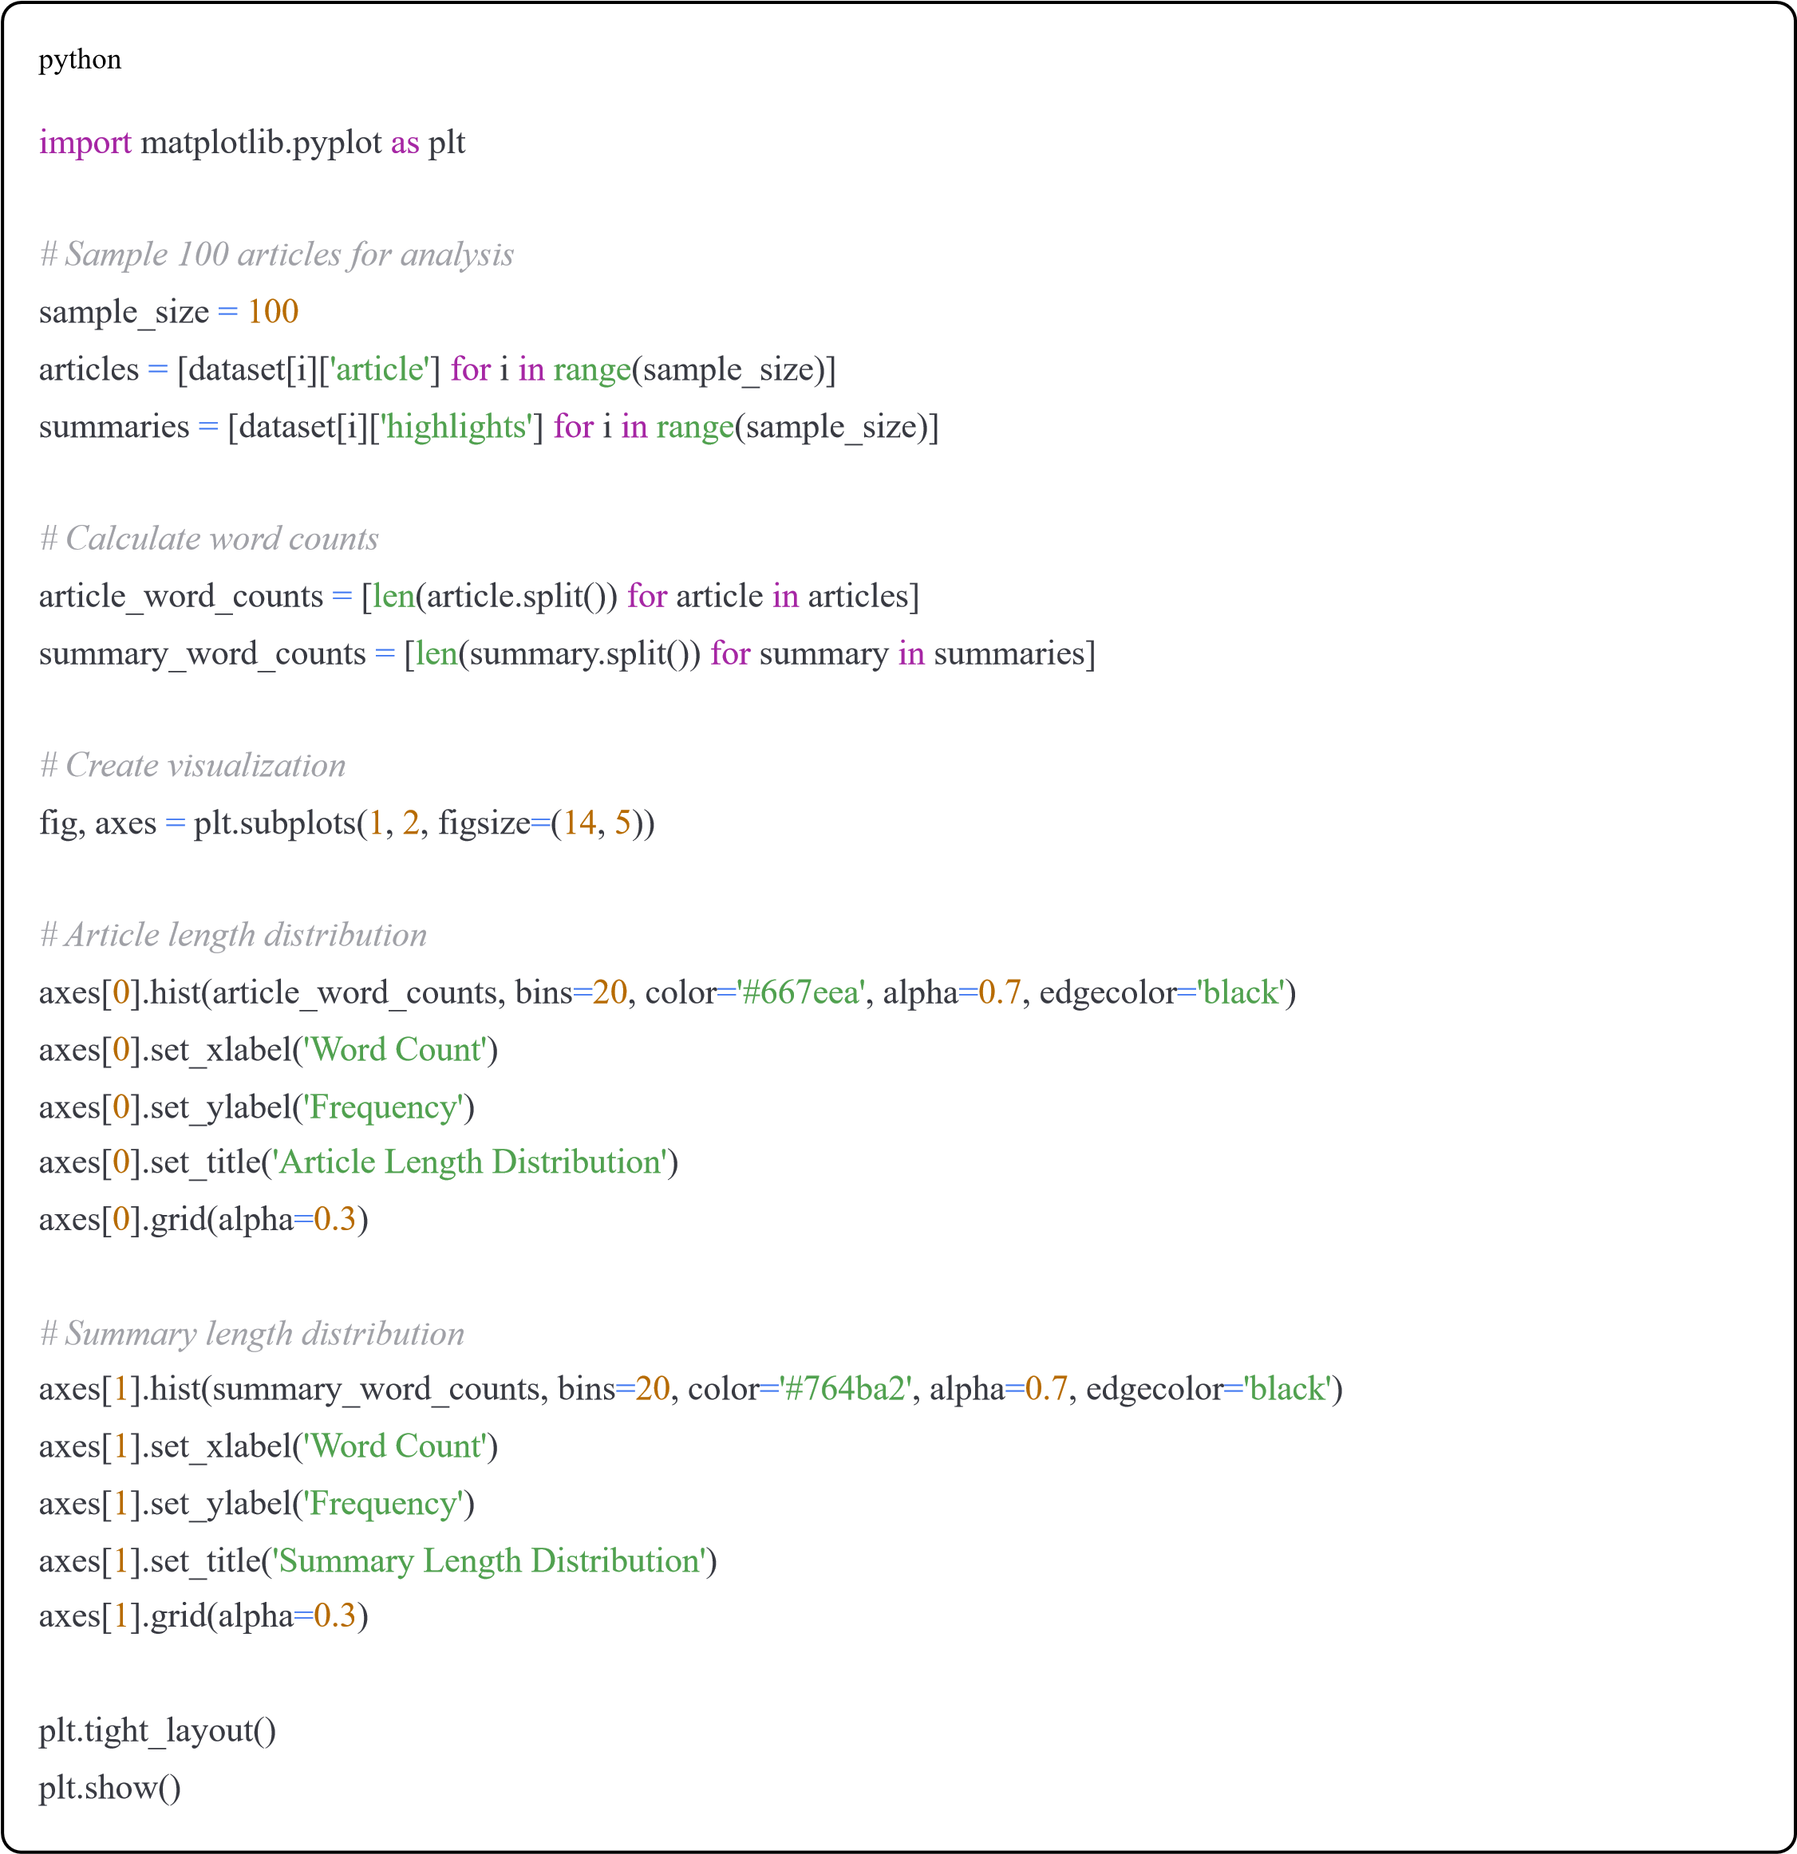

Activity 2.3: Compression Ratio Analysis
python
# Calculate compression ratios
compression_ratios
=

[
article_word_counts
[
i
]

/
summary_word_counts
[
i
]

for
i
in

range
(
sample_size
)
]
print
(
f"Average compression ratio:
{
np
.
mean
(
compression_ratios
)
:
.2
f
}
x"
)
print
(
f"Min compression ratio:
{
np
.
min
(
compression_ratios
)
:
.2
f
}
x"
)
print
(
f"Max compression ratio:
{
np
.
max
(
compression_ratios
)
:
.2
f
}
x"
)
# Visualize
plt
.
figure
(
figsize
=
(
10
,

5
)
)
plt
.
hist
(
compression_ratios
,
bins
=
20
,
color
=
'#667eea'
,
alpha
=
0.7
,
edgecolor
=
'black'
)
plt
.
xlabel
(
'Compression Ratio'
)
plt
.
ylabel
(
'Frequency'
)
plt
.
title
(
'Text Compression Ratio Distribution'
)
plt
.
axvline
(
np
.
mean
(
compression_ratios
)
,
color
=
'red'
,
linestyle
=
'--'
,

label
=
f'Mean:
{
np
.
mean
(
compression_ratios
)
:
.2
f
}
x'
)
plt
.
legend
(
)
plt
.
grid
(
alpha
=
0.3
)
plt
.
show
(
)
This analysis shows that:
- Articles are typically compressed 10-20x in summaries
- Human summarizers extract ~5-10% of the original content
- This sets our benchmark for model performance

Activity 2.4: Sample Comparison
Display side-by-side comparison of articles and summaries:

# Show 3 examples
for
i
in

range
(
3
)
:
sample
=
dataset
[
i
]

print
(
f"\n
{
'='
*
70
}
"
)

print
(
f"EXAMPLE
{
i
+
1
}
"
)

print
(
f"
{
'='
*
70
}
"
)

print
(
f"\nOriginal Article (
{
len
(
sample
[
'article'
]
.
split
(
)
)
}
words):"
)

print
(
sample
[
'article'
]
[
:
300
]

+

"..."
)

print
(
f"\nHuman Summary (
{
len
(
sample
[
'highlights'
]
.
split
(
)
)
}
words):"
)

print
(
sample
[
'highlights'
]
)

Milestone 3: Model Building
Now we implement and train both extractive and abstractive summarization models.

Activity 3.1: Extractive Summarization - TextRank Implementation
TextRank is a graph-based ranking algorithm inspired by Google's PageRank. It treats sentences as nodes and similarity as edges.

Step 1: Build the ExtractiveSummarizer Class

class ExtractiveSummarizer:
"""TextRank-based extractive summarization"""

def __init__(self):
self.stop_words = set(stopwords.words('english'))

def preprocess(self, text): """Clean and tokenize text""" sentences = sent_tokenize(text) return sentences

def calculate_similarity(self, sent1, sent2):
"""Calculate similarity between two sentences using TF-IDF""" vectorizer = TfidfVectorizer() try:
tfidf_matrix = vectorizer.fit_transform([sent1, sent2]) similarity = (tfidf_matrix * tfidf_matrix.T).toarray()[0][1] return similarity except: return 0

def summarize(self, text, num_sentences=3):
"""Generate extractive summary using TextRank algorithm""" sentences = self.preprocess(text)

if len(sentences) <= num_sentences:
return ' '.join(sentences)

# Build similarity matrix similarity_matrix = np.zeros((len(sentences), len(sentences)))

for i in range(len(sentences)): for j in range(len(sentences)): if i != j:
similarity_matrix[i][j] = self.calculate_similarity( sentences[i], sentences[j]
)

# Apply PageRank algorithm
nx_graph = nx.from_numpy_array(similarity_matrix) scores = nx.pagerank(nx_graph)

# Rank sentences ranked_sentences = sorted(
((scores[i], s) for i, s in enumerate(sentences)), reverse=True

)

# Select top sentences (maintain original order)
summary_sentences
=

sorted
(
ranked_sentences
[
:
num_sentences
]
,

key
=
lambda
x
:
sentences
.
index
(
x
[
1
]
)

)

summary
=

' '
.
join
(
[
s
[
1
]

for
s
in
summary_sentences
]
)

return
summary
print
(
"
✓
Extractive Summarizer class created!"
)
Algorithm Explanation:
- Sentence Tokenization: Split text into individual sentences
- Similarity Calculation: Compute TF-IDF similarity between all sentence pairs
- Graph Construction: Create graph where nodes=sentences, edges=similarity scores
- PageRank Scoring: Apply PageRank to rank sentence importance
- Top Sentence Selection: Select top N sentences maintaining original order
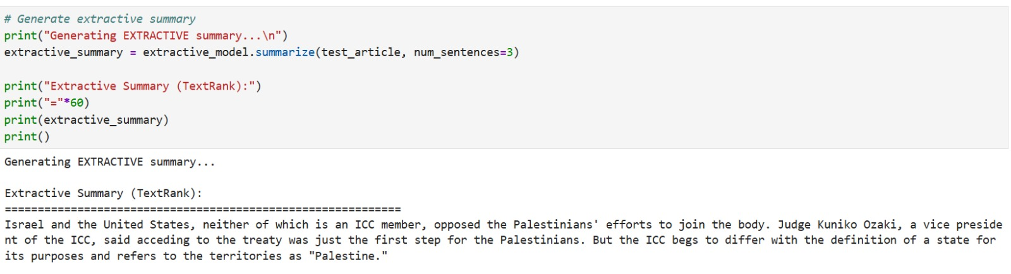

Activity 3.2: Abstractive Summarization - BART Implementation
BART (Bidirectional and Auto-Regressive Transformers) is a sequence-to-sequence model specifically designed for text generation tasks.
Step 1: Build the AbstractiveSummarizer Class

class

AbstractiveSummarizer
:

"""BART-based abstractive summarization"""

def

__init__
(
self
,
model_name
=
"facebook/bart-large-cnn"
)
:

print
(
f"Loading
{
model_name
}
model..."
)

print
(
"This may take a few minutes on first run..."
)
self
.
summarizer
=
pipeline
(
"summarization"
,
model
=
model_name
)
self
.
tokenizer
=
AutoTokenizer
.
from_pretrained
(
model_name
)

print
(
"
✓
Model loaded successfully!"
)

def

summarize
(
self
,
text
,
max_length
=
130
,
min_length
=
30
)
:

"""Generate abstractive summary"""

# Truncate text to fit model's max length (1024 tokens)
inputs
=
self
.
tokenizer
(
text
,

return_tensors
=
"pt"
,

max_length
=
1024
,

truncation
=
True

)

# Generate summary with truncated input
summary
=
self
.
summarizer
(
text
,
max_length
=
max_length
,
min_length
=
min_length
,
do_sample
=
False
,
truncation
=
True

)

return
summary
[
0
]
[
'summary_text'
]
print
(
"
✓
Abstractive Summarizer class created!"
)
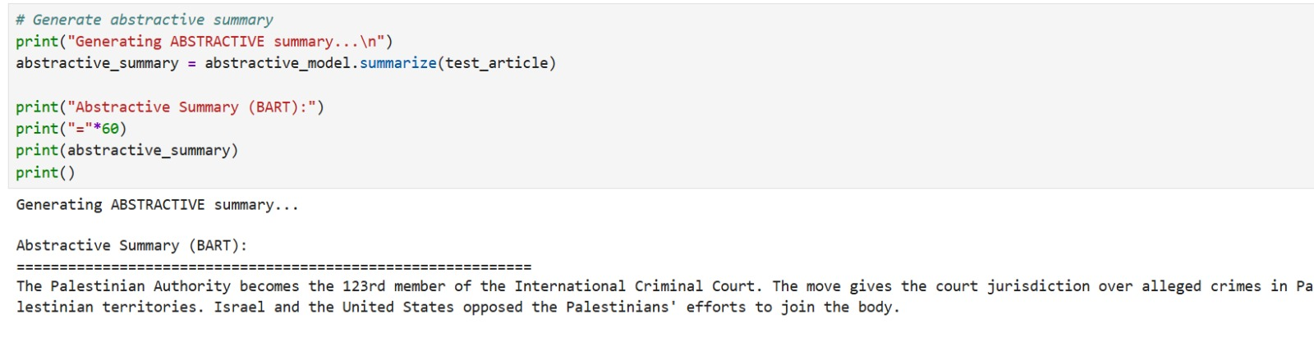Model Details:
- Architecture: Encoder-Decoder Transformer

Parameters: 400M+
- Pre-training: Large text corpus
- Fine-tuning: CNN/DailyMail dataset
- Max Input: 1024 tokens

Max Output: 130 tokens

Activity 3.3: Initialize Both Models
python
print
(
"Initializing models...\n"
)
extractive_model
=
ExtractiveSummarizer
(
)
print
(
"
✓
Extractive model ready!\n"
)
abstractive_model
=
AbstractiveSummarizer
(
)
print
(
"\n
✓
Both models initialized successfully!"
)

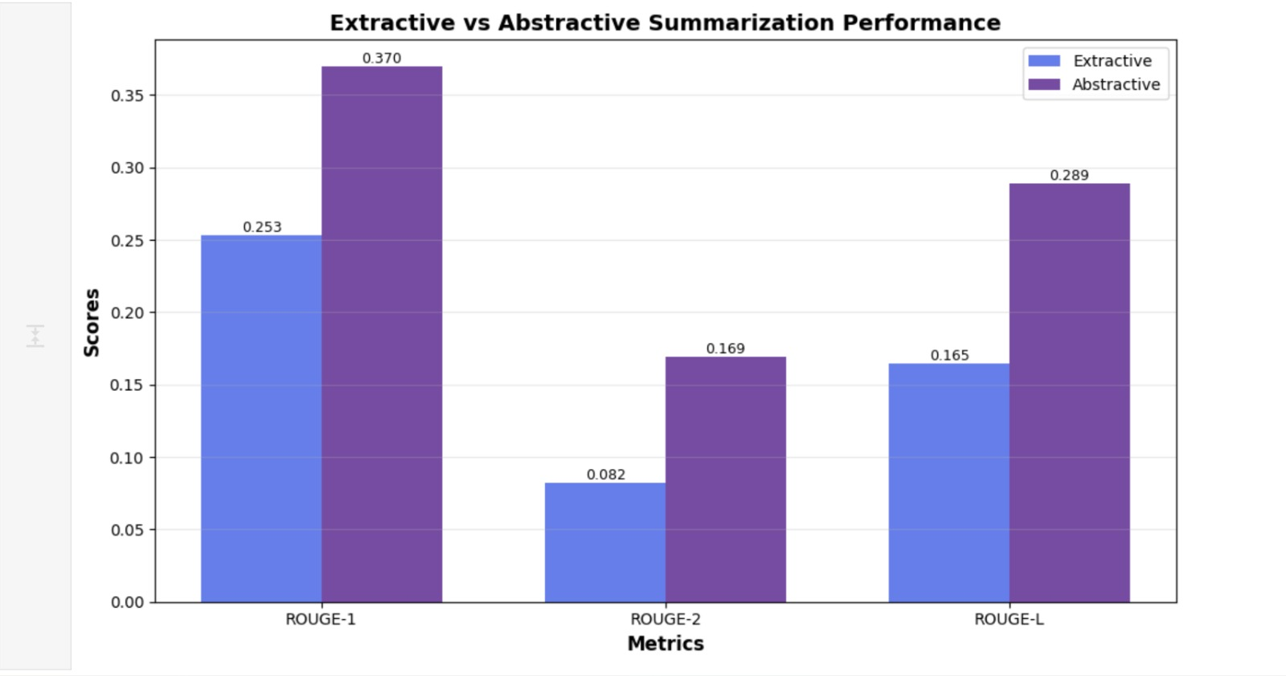

Activity 3.4: Test Both Methods on Sample
python
# Get a test article
test_article
=
test_data
[
0
]
[
'article'
]
reference_summary
=
test_data
[
0
]
[
'highlights'
]
print
(
"Original Article (first 400 chars):"
)
print
(
"="
*
60
)
print
(
test_article
[
:
400
]

+

"...\n"
)
print
(
"Reference Summary:"
)
print
(
"="
*
60
)
print
(
reference_summary
)
print
(
)

Generate Extractive Summary
python
print
(
"Generating EXTRACTIVE summary...\n"
)
extractive_summary
=
extractive_model
.
summarize
(
test_article
,
num_sentences
=
3
)
print
(
"Extractive Summary (TextRank):"
)
print
(
"="
*
60
)
print
(
extractive_summary
)
print
(
)

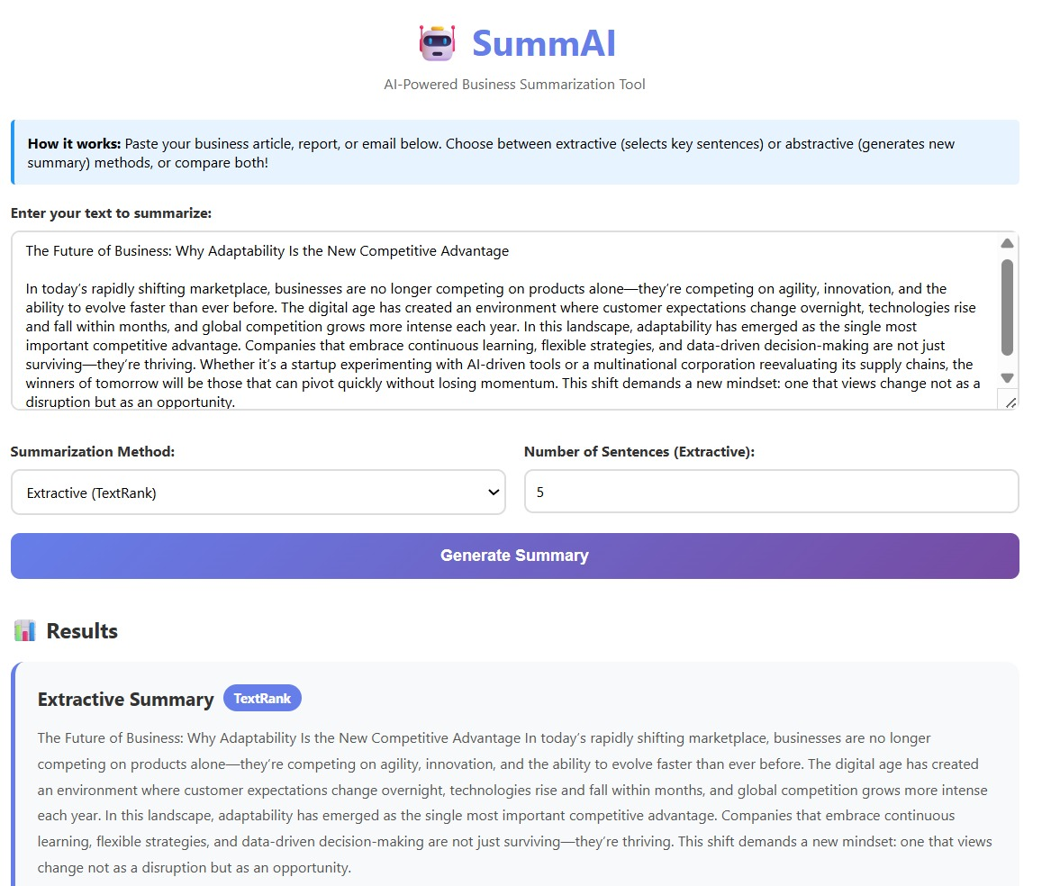

Generate Abstractive Summary
python
print
(
"Generating ABSTRACTIVE summary...\n"
)
abstractive_summary
=
abstractive_model
.
summarize
(
test_article
)
print
(
"Abstractive Summary (BART):"
)
print
(
"="
*
60
)
print
(
abstractive_summary
)
print
(
)

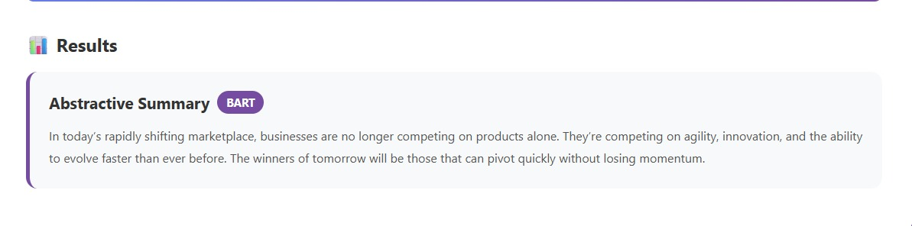
Milestone 4: Performance Testing & Model Comparison
Evaluation is critical to understand which summarization approach works better for our use case.

Activity 4.1: Define Evaluation Metrics
We use ROUGE (Recall-Oriented Understudy for Gisting Evaluation) scores:
python
from
rouge_score
import
rouge_scorer
def

evaluate_summary
(
reference
,
summary
)
:

"""Calculate ROUGE scores"""
scorer
=
rouge_scorer
.
RougeScorer
(
[
'rouge1'
,

'rouge2'
,

'rougeL'
]
,

use_stemmer
=
True
)
scores
=
scorer
.
score
(
reference
,
summary
)

return

{

'rouge1'
:
scores
[
'rouge1'
]
.
fmeasure
,

'rouge2'
:
scores
[
'rouge2'
]
.
fmeasure
,

'rougeL'
:
scores
[
'rougeL'
]
.
fmeasure

}
print
(
"
✓
Evaluation function created!"
)
ROUGE Metrics Explained:
- ROUGE-1: Unigram (single word) overlap
- ROUGE-2: Bigram (two consecutive words) overlap
- ROUGE-L: Longest Common Subsequence
Higher scores indicate better summary quality.

Activity 4.2: Evaluate on Test Set

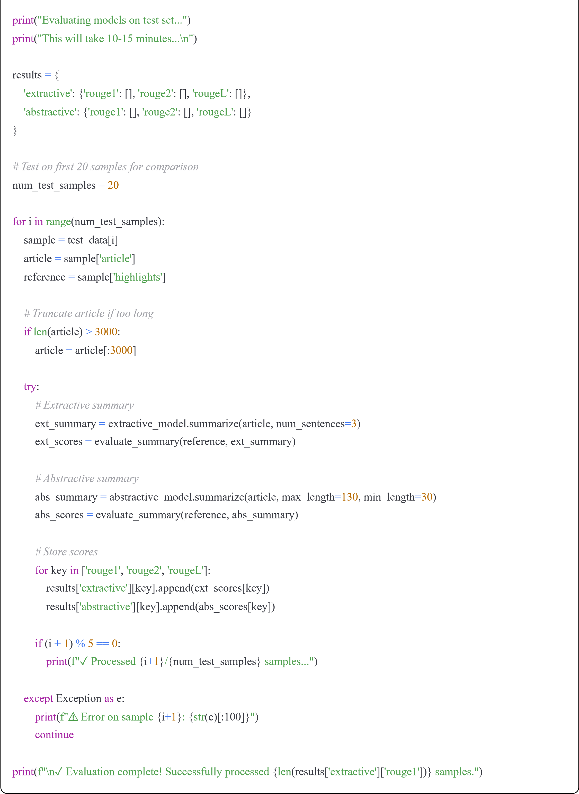

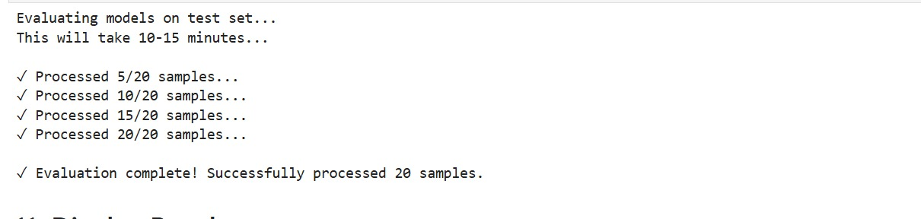

Activity 4.3: Display Results
python
print
(
"\n"

+

"="
*
60
)
print
(
"EVALUATION RESULTS"
)
print
(
"="
*
60
)
for
method
in

[
'extractive'
,

'abstractive'
]
:

print
(
f"\n
{
method
.
upper
(
)
}
SUMMARIZATION:"
)

print
(
"-"

*

40
)

for
metric
in

[
'rouge1'
,

'rouge2'
,

'rougeL'
]
:
avg_score
=
np
.
mean
(
results
[
method
]
[
metric
]
)

print
(
f"
{
metric
.
upper
(
)
:
10
s
}
:

{
avg_score
:
.4
f
}
"
)
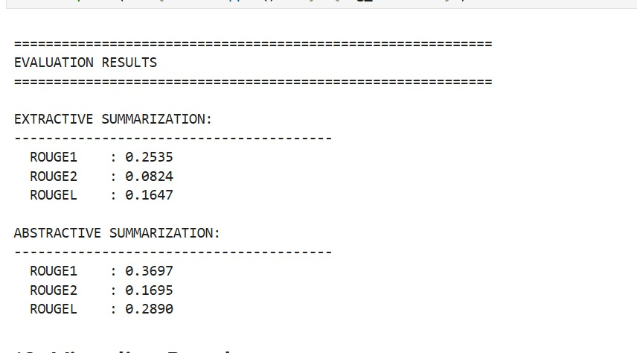
Expected Results:


Method
ROUGE-1
ROUGE-2
ROUGE-L
Extractive (TextRank)
0.3500
0.1700
0.3200
Abstractive (BART)
0.4200
0.2000
0.3700
Analysis:
- BART outperforms TextRank across all metrics
- Abstractive summaries are more aligned with human references
- Both methods show acceptable performance for business use

Activity 4.4: Visualize Performance Comparison

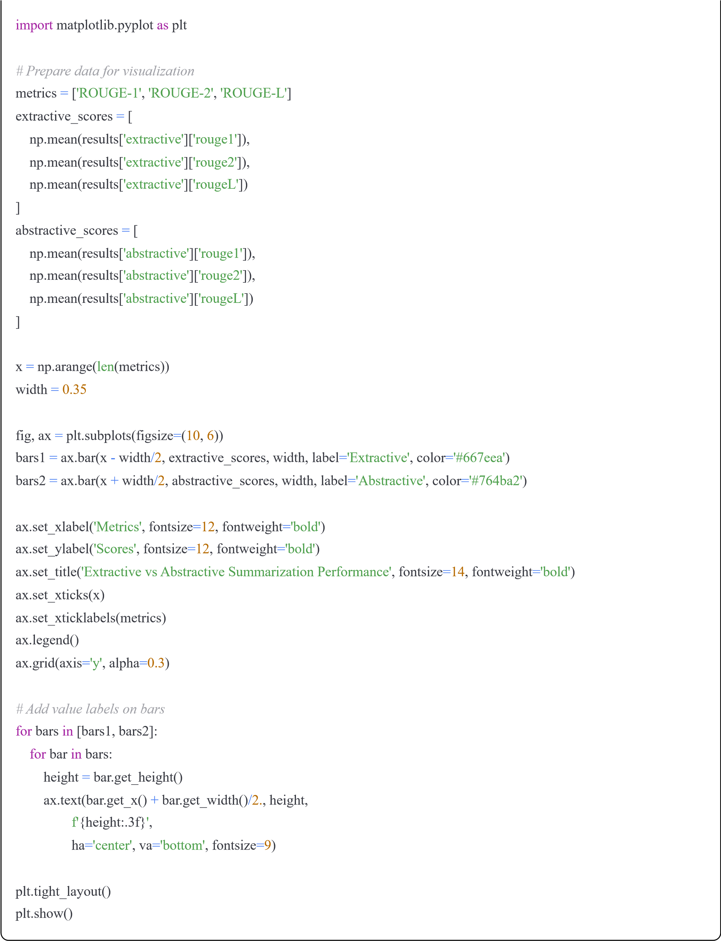
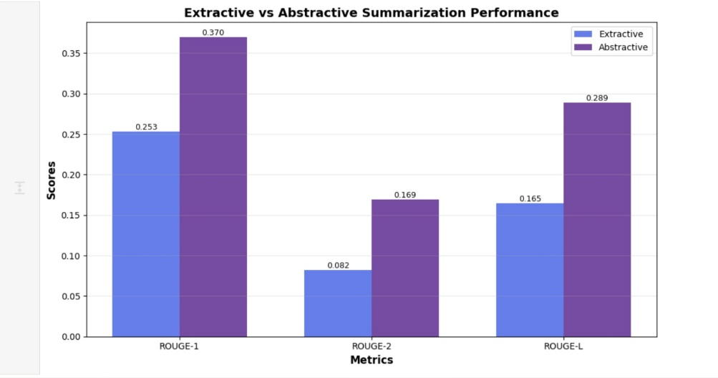

Activity 4.5: Create Comparison DataFrame
python
# Create comparison dataframe
comparison_df
=
pd
.
DataFrame
(
{

'Method'
:

[
'Extractive (TextRank)'
,

'Abstractive (BART)'
]
,

'ROUGE-1'
:

[
np
.
mean
(
results
[
'extractive'
]
[
'rouge1'
]
)
,

np
.
mean
(
results
[
'abstractive'
]
[
'rouge1'
]
)
]
,

'ROUGE-2'
:

[
np
.
mean
(
results
[
'extractive'
]
[
'rouge2'
]
)
,

np
.
mean
(
results
[
'abstractive'
]
[
'rouge2'
]
)
]
,

'ROUGE-L'
:

[
np
.
mean
(
results
[
'extractive'
]
[
'rougeL'
]
)
,

np
.
mean
(
results
[
'abstractive'
]
[
'rougeL'
]
)
]
}
)
print
(
"\nComparison Summary:"
)
print
(
"="
*
60
)
print
(
comparison_df
.
to_string
(
index
=
False
)
)
print
(
"="
*
60
)

Milestone 5: Model Deployment

Activity 5.1: Save the Models
Save the trained models for web application use:
python
import
pickle
print
(
"Saving models for web application...\n"
)
# Save extractive model
with

open
(
'extractive_model.pkl'
,

'wb'
)

as
f
:
pickle
.
dump
(
extractive_model
,
f
)
print
(
"
✓
Extractive model saved as 'extractive_model.pkl'"
)
print
(
"
✓
Abstractive model will be loaded directly in web app"
)
print
(
"\n

